**Shrija Chavan**

**A20381511**

**ITMD 521**

**Week 05**

Below are the screen shots explaining all the steps of week-05 assignment. The screen shots show the results after executing the following:

1. WordCount.java

2. Modified WordCount.java to show the list of words which appear

more than 4 times

3. WordCount2.java

4. Modified WordCount2.java with case sensitive= true and all the

punctuations and preposition removed by giving the skip command

from the pattern.txt file.

5. The top ten words for all the above 4 steps.

**Note:** All the numeric and non-numeric symbols were included in the pattern.txt.

**Screen shots:**

**WordCount.java:**

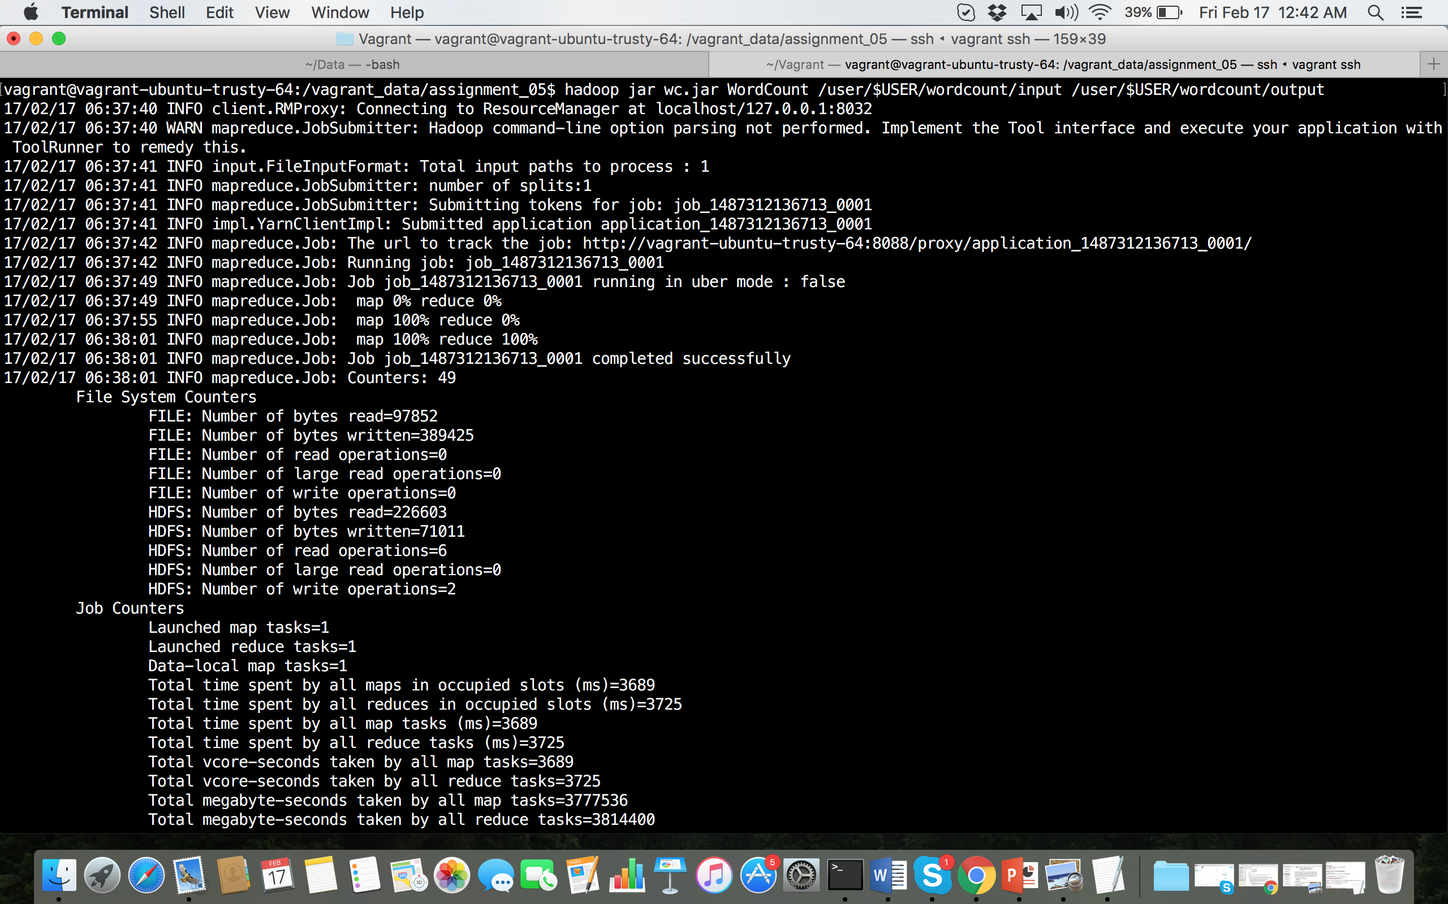

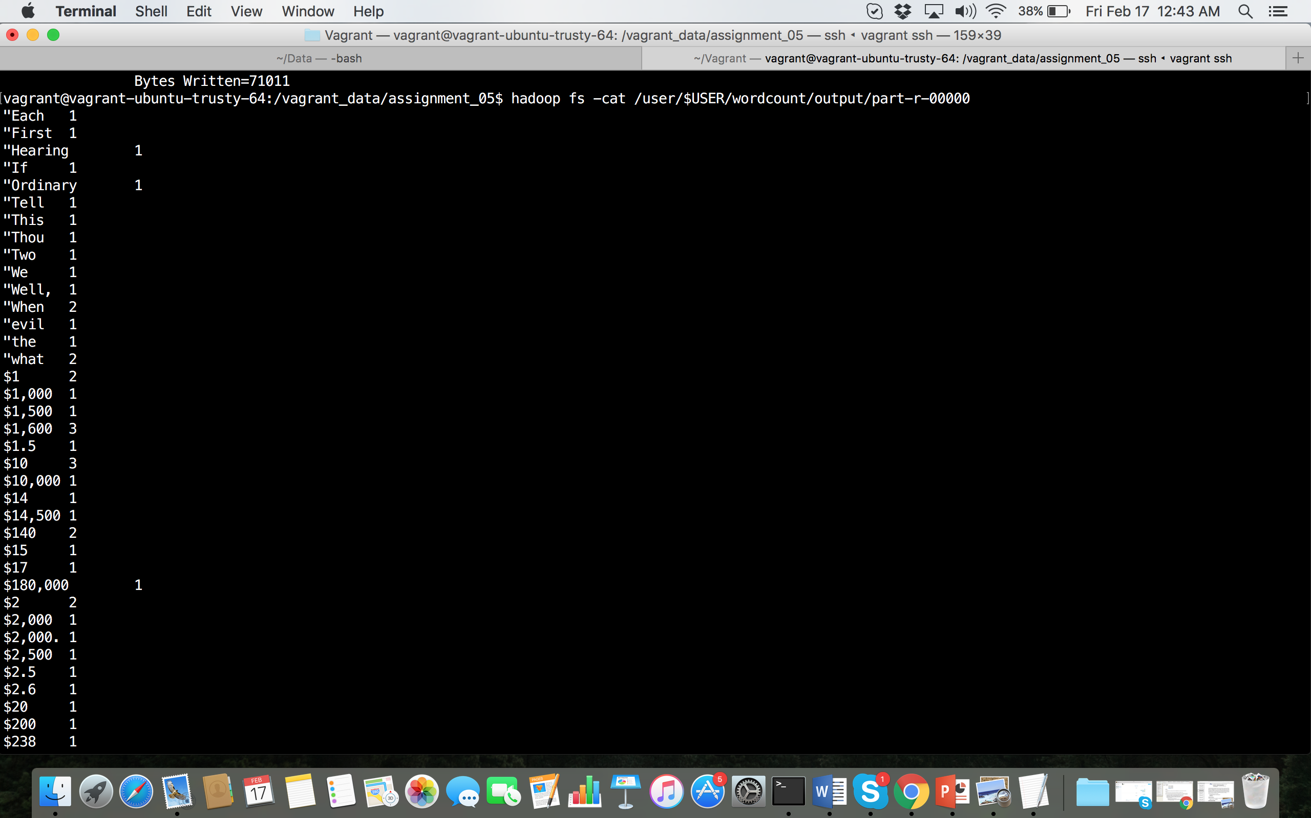

**Top 10 words:**

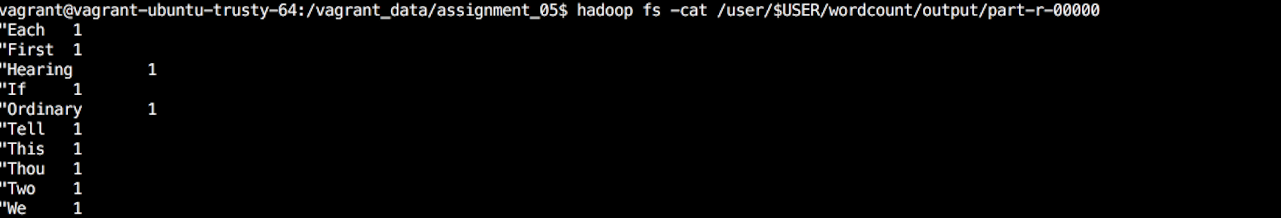

**Modified WordCount.java to show the list of words which appear**

**more than 4 times:**

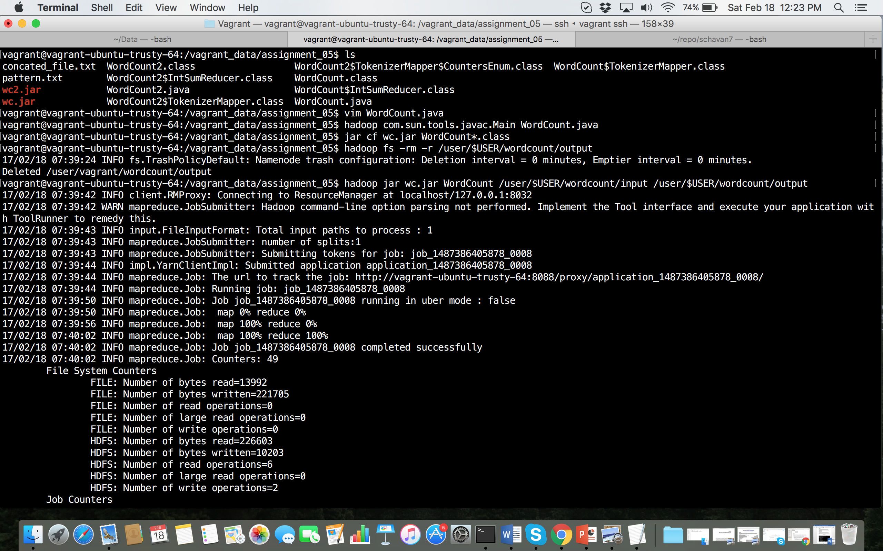

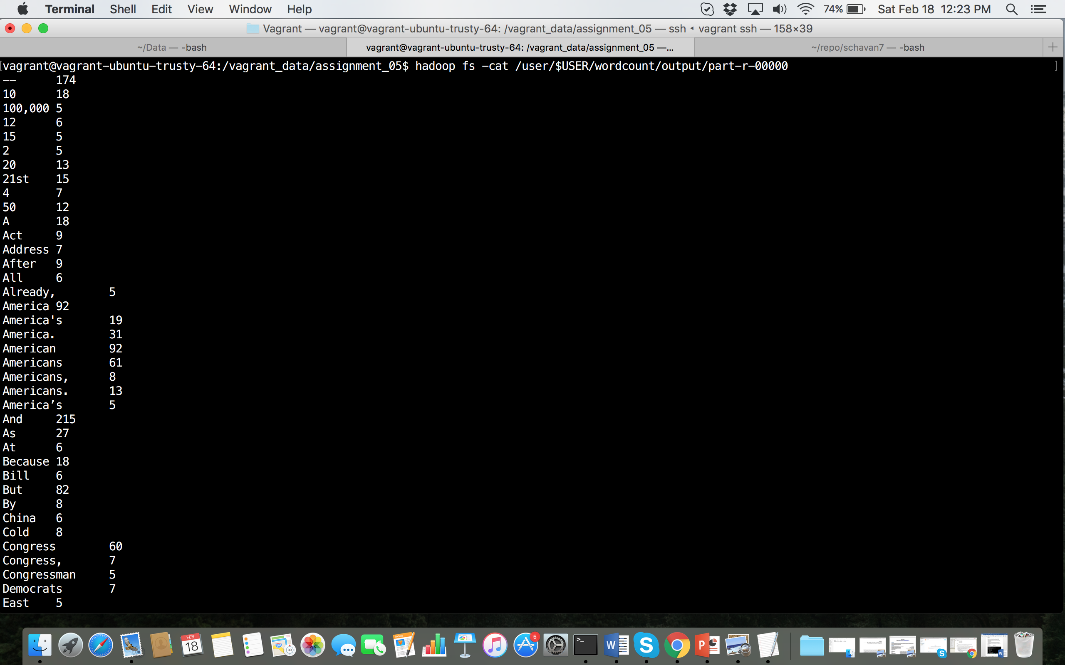

**Top 10 words:**

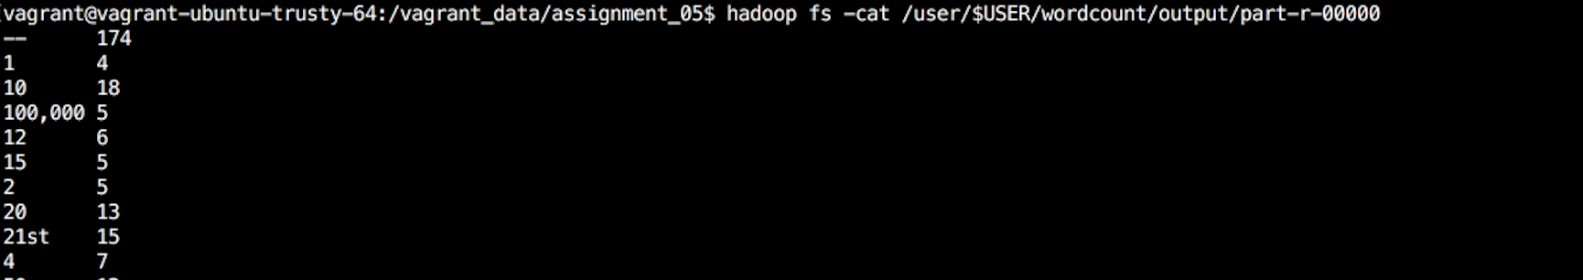

**WordCount2.java**

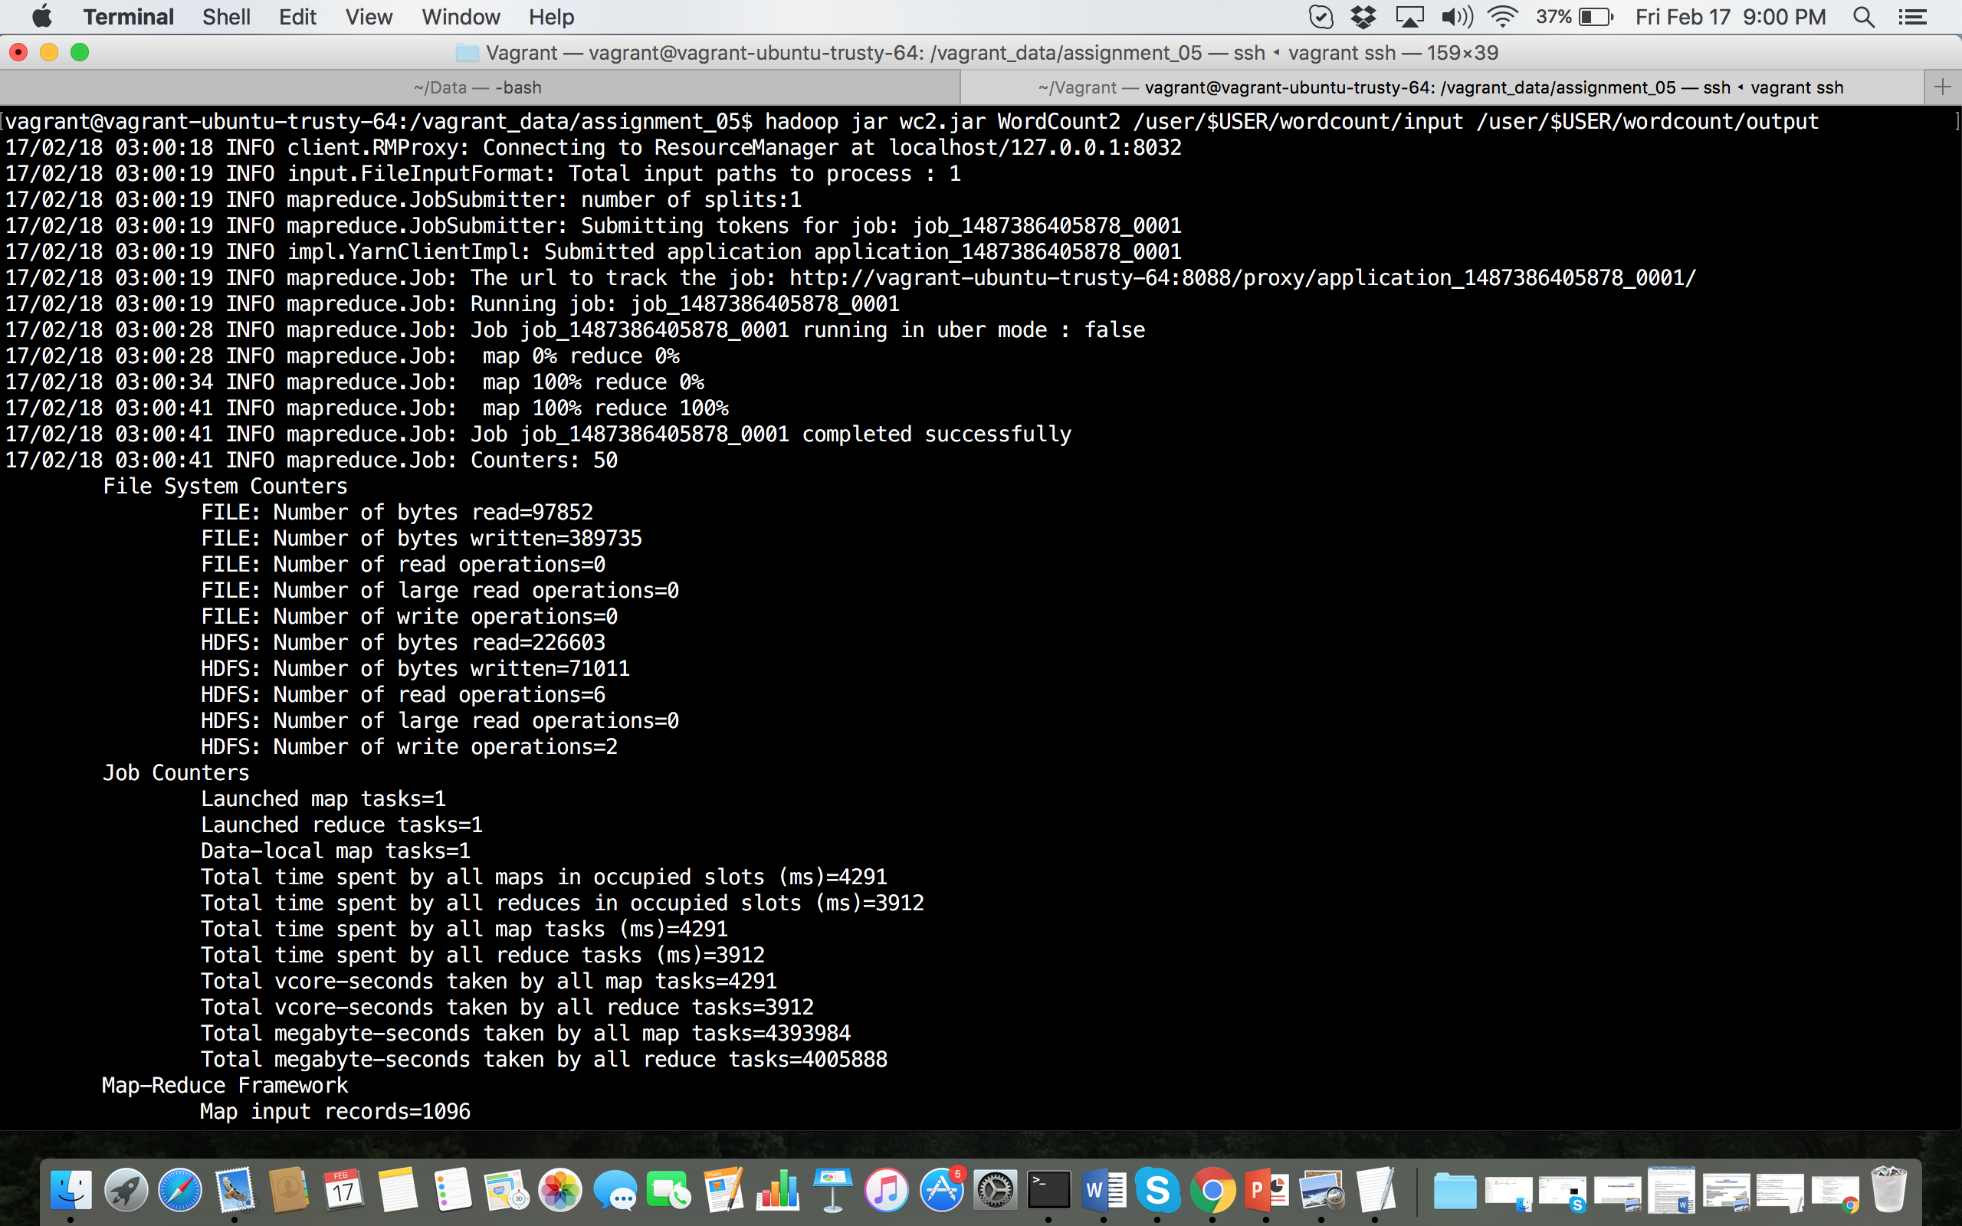

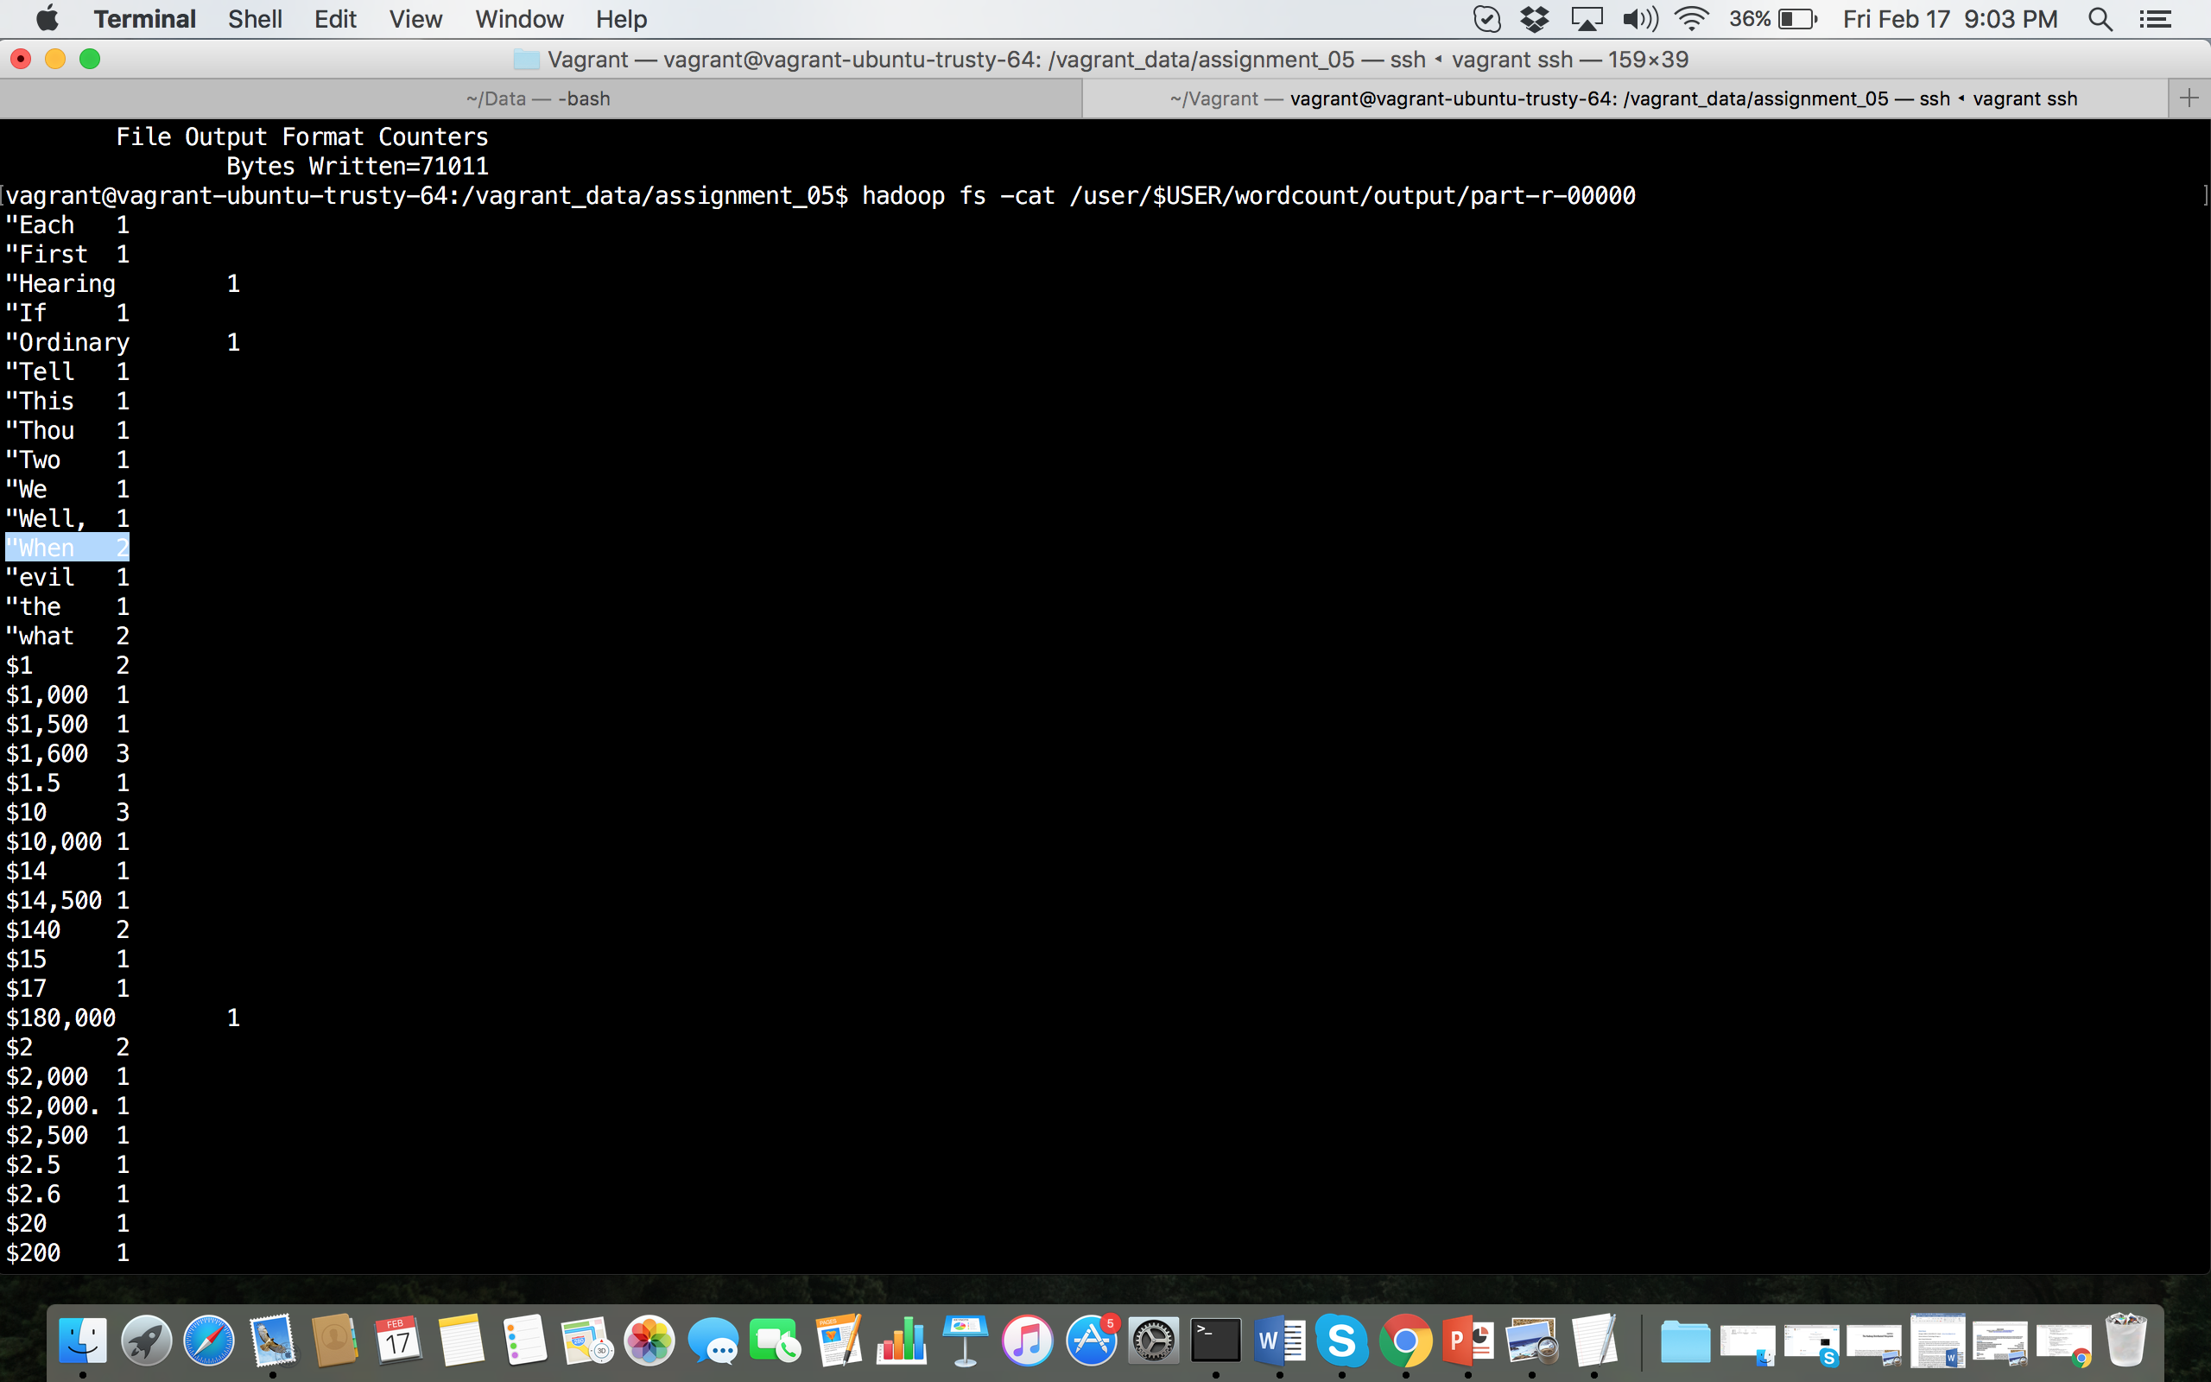

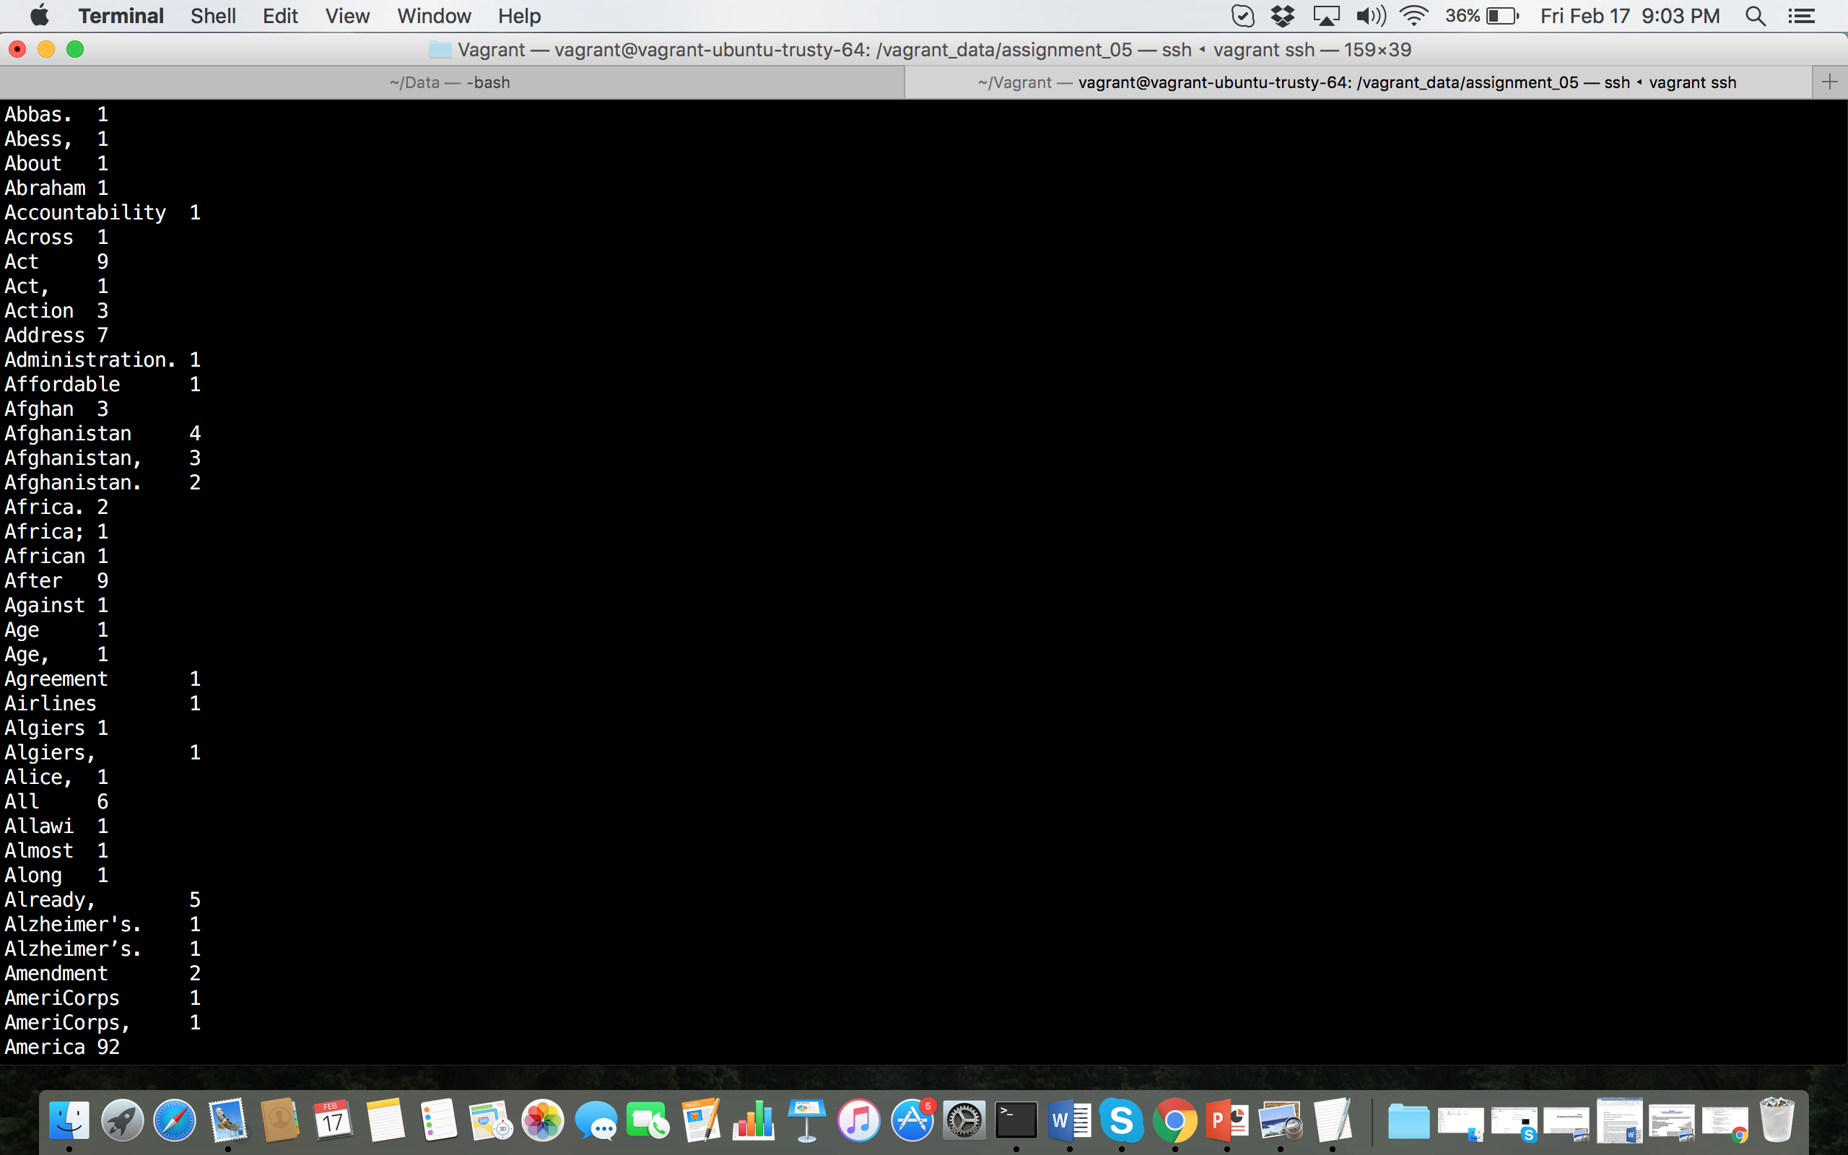

**Top 10 words:**



**Modified WordCount2.java with the case sensitive= true and all the**

**and punctuations and preposition removed by giving the skip command for the pattern.txt file.**

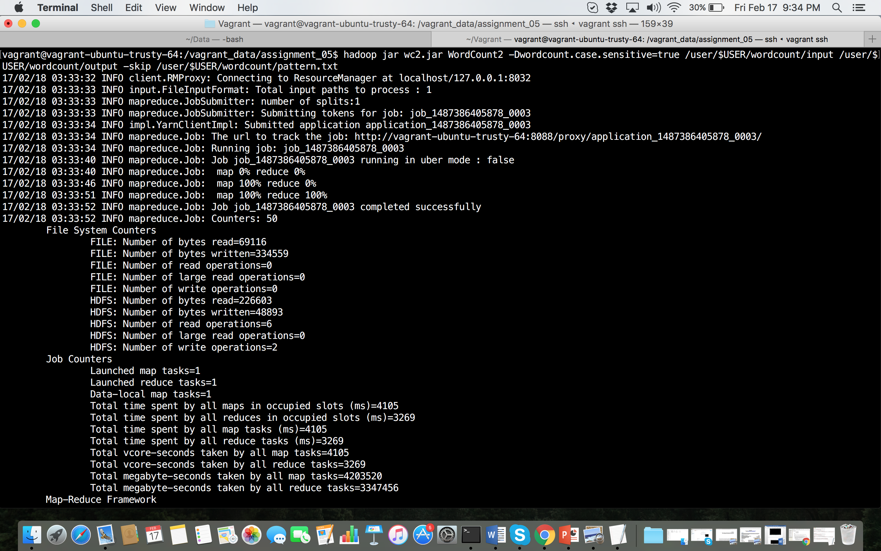

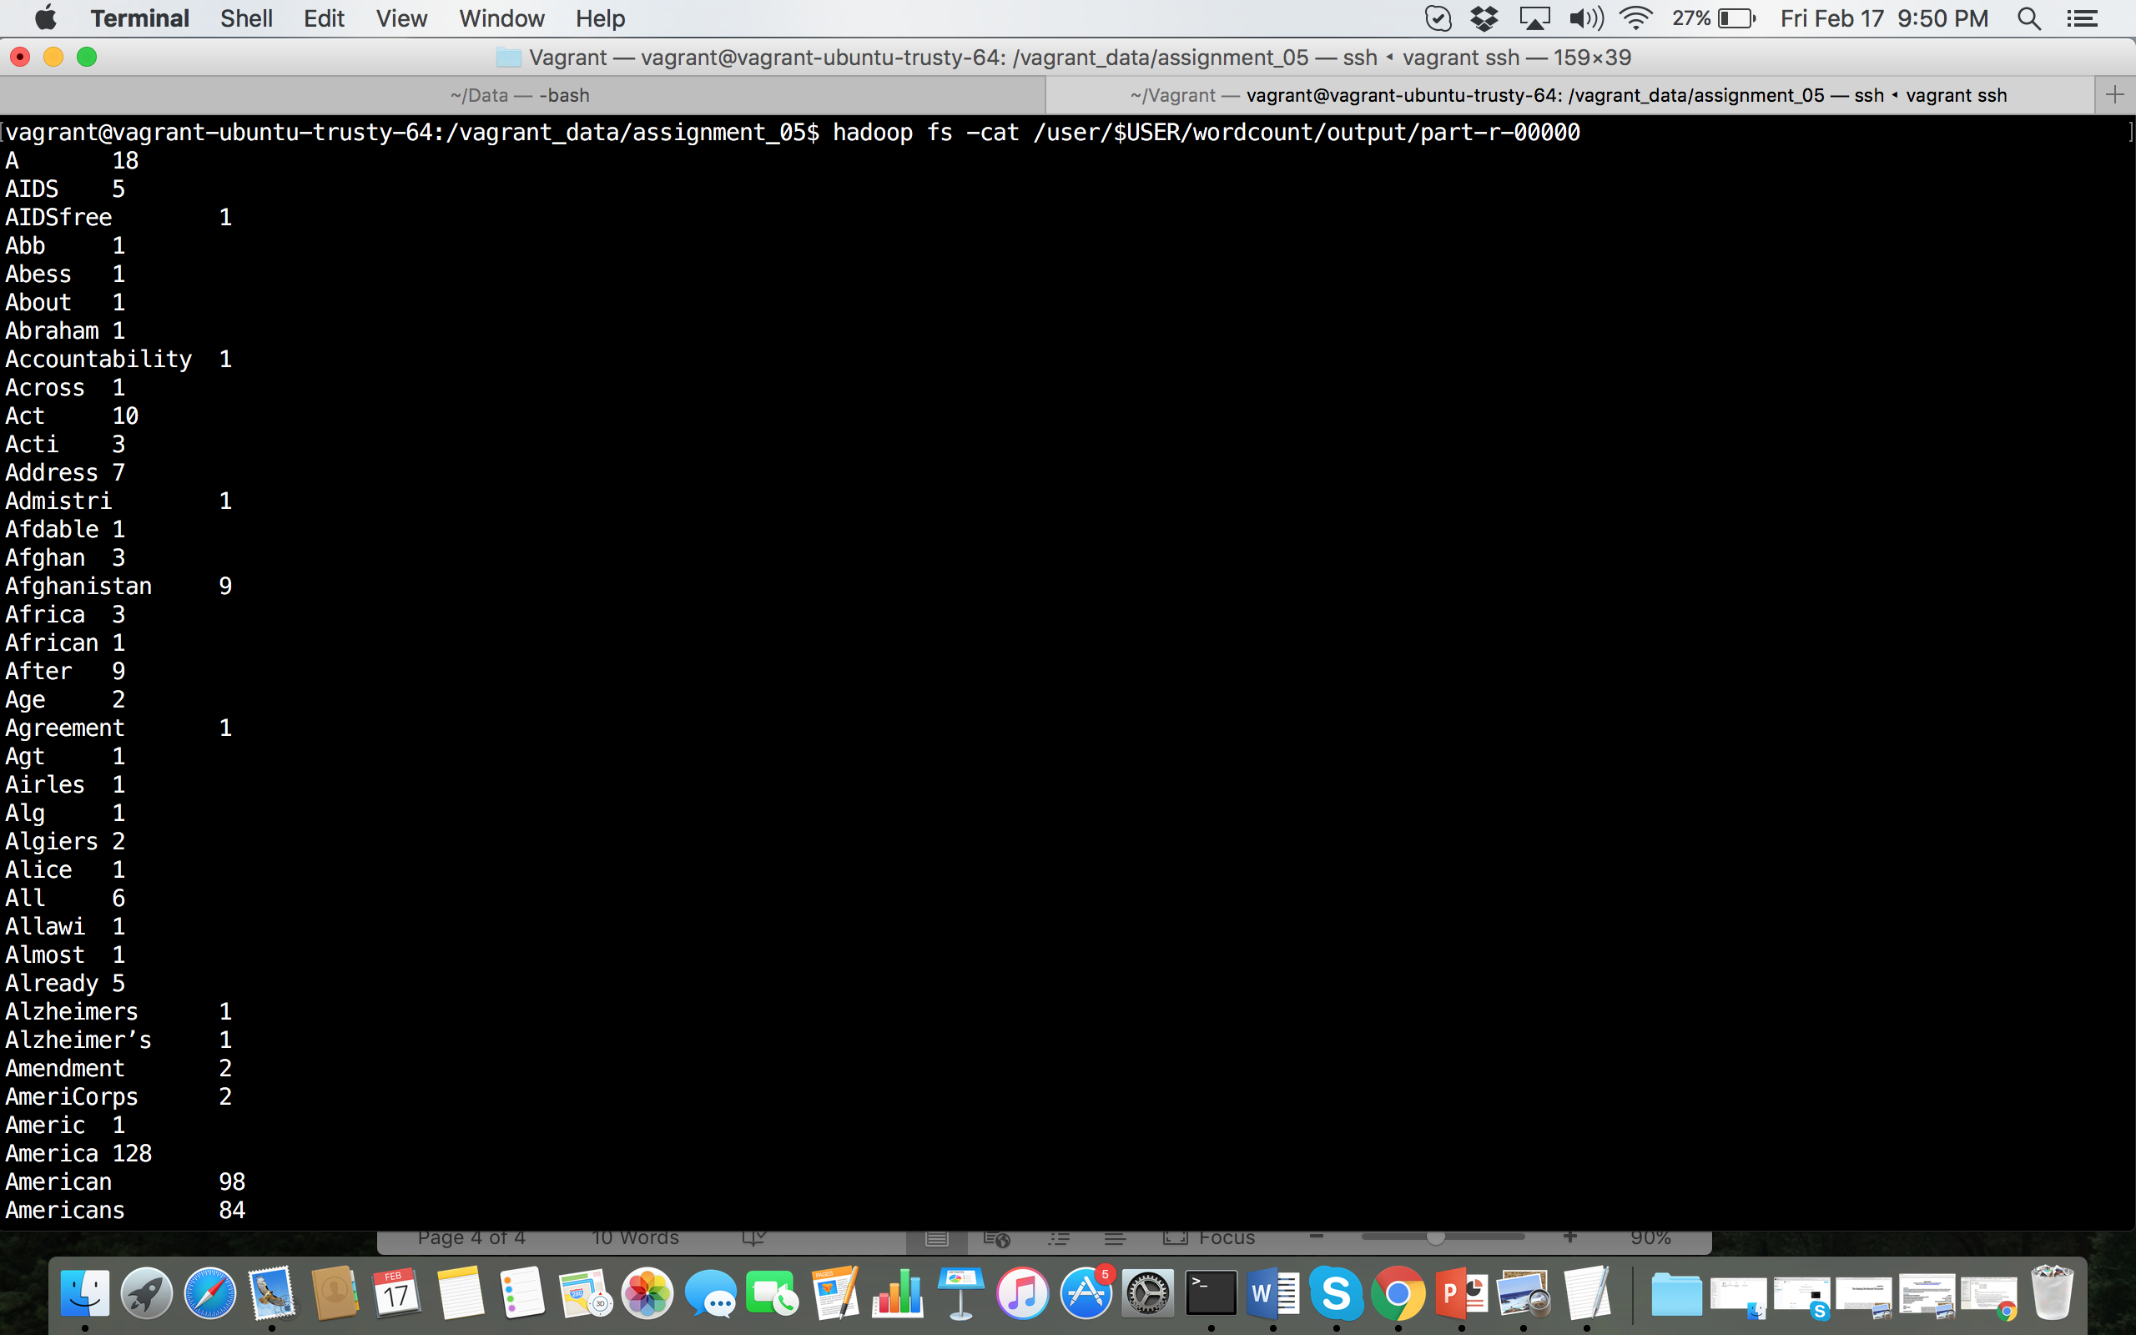

**Top 10 words:**

